**Section 1: Define / Answer**

“programmer created” class- A class is the blueprint from which individual objects are created.

“programmer created” object- A typical Java program creates many objects, which as you know, interact by invoking methods. Through these object interactions, a program can carry out various tasks, such as implementing a GUI, running an animation, or sending and receiving information over a network. Once an object has completed the work for which it was created, its resources are recycled for use by other objects.

“programmer created” method- collection of statements that are grouped together to perform an operation; use to access the static field

Describe the piece of code below is doing:

Vehicle minivan = **new** Vehicle();

creating a vehicle object

void method-

“programmer created” class- How do “programmer created methods” using **void**, differ from using created using **return**? Briefly - Define how return works.

https://docs.oracle.com/javase/tutorial/essential/io/formatting.html

Format Specifier- the sequence passed as the formatting string argument; "Characters matched" gives the format of the sequence sought or printed, with a hyperlink to the section on literals which applies to that format;

**"** **%.**2f **"-** Describe what the statement is saying- Print 2 decimal

“%n”- Describe what the statement is saying- new line

**System.out.format("%.2f%n", b + a); // Example of code**

System.out.format(…); Explain how this method differs from System.out.println

Println couldn’t do the %.2f but format can

Pg. 577**,** Java Programming *A comprehensive Introduction*

[**http://www.oracle.com/technetwork/java/javase/documentation/index-137868.html#format**](http://www.oracle.com/technetwork/java/javase/documentation/index-137868.html#format)(Detailed explanation of Java documentation)

[**http://www.tutorialspoint.com/java/java_documentation.htm**](http://www.tutorialspoint.com/java/java_documentation.htm)

[**http://www.liferay.com/community/wiki/-/wiki/Main/Javadoc+Guidelines#section-Javadoc+Guidelines-Class+Comments**](http://www.liferay.com/community/wiki/-/wiki/Main/Javadoc+Guidelines#section-Javadoc+Guidelines-Class+Comments)

**Javadoc tags (Examples)**

|  |  |  |
| --- | --- | --- |
| **Tag** | **Description** | **Syntax** |
| @author | Adds the author of a class. | @author name-text |
| {@code} | Displays text in code font without interpreting the text as HTML markup or nested javadoc tags. | {@code text} |
| {@docRoot} | Represents the relative path to the generated document's root directory from any generated page | {@docRoot} |
| @deprecated | Adds a comment indicating that this API should no longer be used. | @deprecated deprecated-text |
| @exception | Adds a **Throws** subheading to the generated documentation, with the class-name and description text. | @exception class-name description |
| {@inheritDoc} | Inherits a comment from the **nearest** inheritable class or implementable interface | Inherits a comment from the immediate surperclass. |
| {@link} | Inserts an in-line link with visible text label that points to the documentation for the specified package, class or member name of a referenced class. T | {@link package.class#member label} |
| {@linkplain} | Identical to {@link}, except the link's label is displayed in plain text than code font. | {@linkplain package.class#member label} |
| @param | Adds a parameter with the specified parameter-name followed by the specified description to the "Parameters" section. | @param parameter-name description |
| @return | Adds a "Returns" section with the description text. | @return description |
| @see | Adds a "See Also" heading with a link or text entry that points to reference. | @see reference |
| @serial | Used in the doc comment for a default serializable field. | @serial field-description | include | exclude |
| @serialData | Documents the data written by the writeObject( ) or writeExternal( ) methods | @serialData data-description |
| @serialField | Documents an ObjectStreamField component. | @serialField field-name field-type field-description |
| @since | Adds a "Since" heading with the specified since-text to the generated documentation. | @since release |
| @throws | The @throws and @exception tags are synonyms. | @throws class-name description |
| {@value} | When {@value} is used in the doc comment of a static field, it displays the value of that constant: | {@value package.class#field} |
| @version | Adds a "Version" subheading with the specified version-text to the generated docs when the -version option is used. | @version version-text |

Pg. 123, Java Programming *A comprehensive Introduction*

**Programming Assignment**

Task 1- Create a computer program that will calculate the range for 3 different vehicles.

The program should create a “programmer created” class, where 3 **int** **objects** are created passengers, fuel capacity, mpg.

Create a **void()** method inside the “programmer created “ class to calculate vehicle range**.**

Create a second void() that averages the number of passengers, the fuel capacity, and mpg among the 3 vehicle objects.

**range =** **fuel capacity * miles per gallon**.

Each Vehicle type should have unique values for number of passengers, fuel capacity, and miles per gallon.

Follow the sample below and return information on 3 vehicle types.

**Sample Output: // Create similar output for 3 Vehicle Types**

The minivan carries= 7

The minivan has a fuel capacity of = 16

The minivan mpg = 21

The minivan has a range of: 336 miles

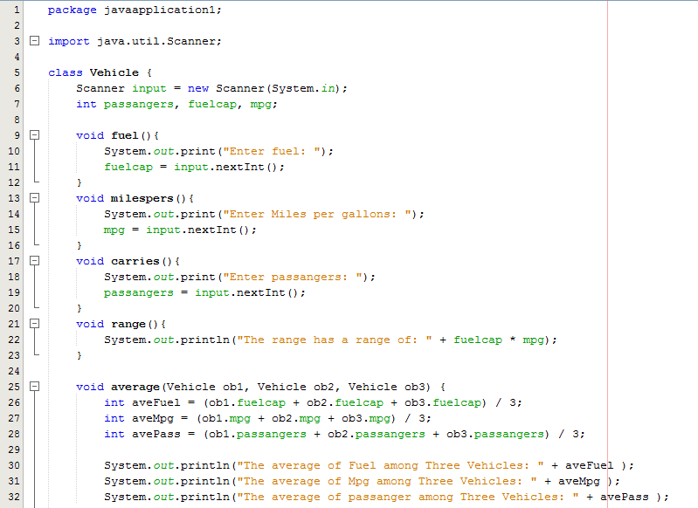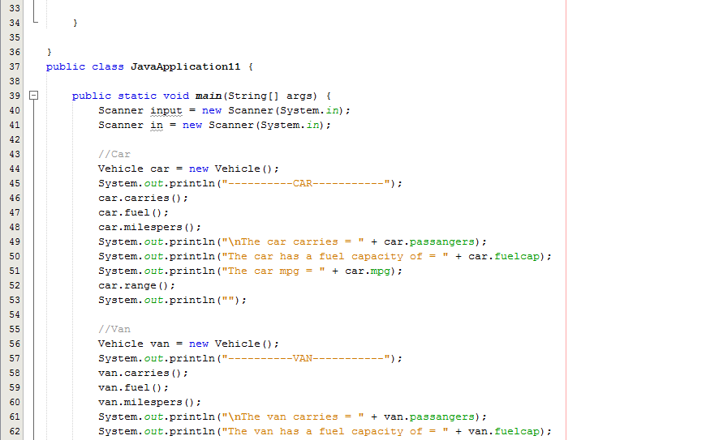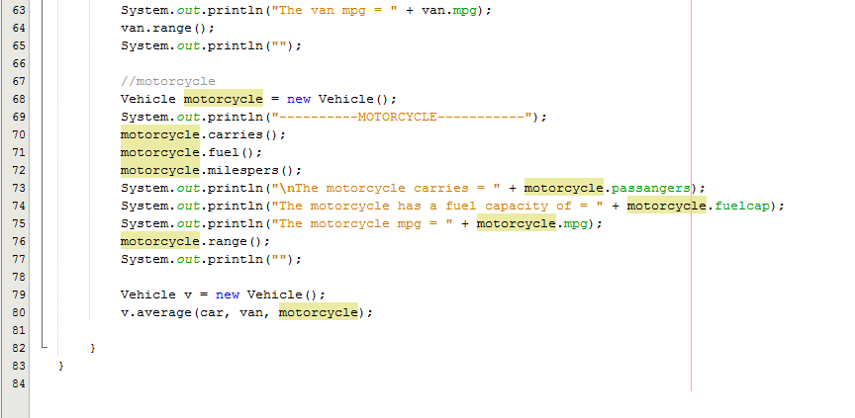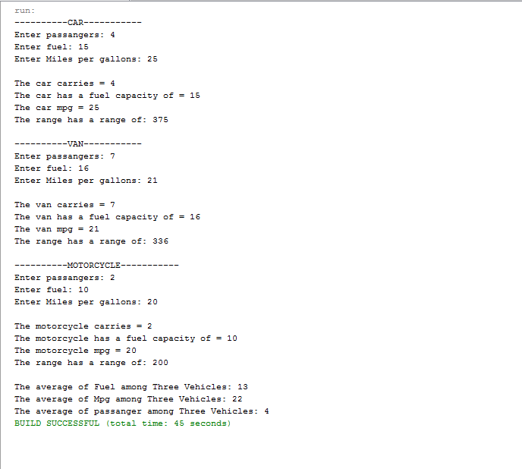

Task 2: Write a program that computes a single filer’s income tax burden.

|  |  |
| --- | --- |
| **TAX RATE** | **Single Filers Income** |
| 10% | Up to $6000 |
| 15% | $6,001 - $27,950 |
| 27% | $27,951 - $67,700 |
| 30% | $67,701 - $141,250 |
| 35% | $141,251 - $307,050 |
| 38.6% | $307, 051 or more |

The user should be able input her income using **new** Scanner (System.in), input method and then be returned the amount of tax owed.

All source code for solving the problem and handling user input should be created in a “programmer created class.”

Use **return** for retrieving all values from calculations or **if/else** statements etc.

**main** will be used to operate the program.

Output should have proper formatting for dollars, 2 decimal places.

**Sample Output- //**Output should have proper formatting for dollars, 2 decimal places

Income tax for a single person making $85000.00 is $25500.00

Income tax for a single person making $9800.00 is $1470.00

